Functions
Function - Functions in JavaScript are reusable blocks of code that perform a specific task or calculate a value. They are fundamental building blocks used to organize and modularize code, allowing it to be called multiple times without repetition. A function is defined once but only executes when it is called or invoked.
- Parameters and Arguments: Functions can accept input via parameters (placeholders in the function definition) and arguments (actual values passed during the call).
- Return Values: The return statement is used to send a value back to the code that called the function, ending the function's execution at that point. If a function does not have a return statement, it implicitly returns undefined.
Syntax for function -
function function_name (parameters){
//statements
}
function_name(arguments)

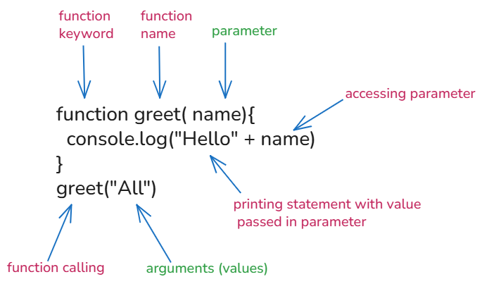

Different types of a function -
- Function declaration - Named function - In this function we are providing / assigning some name to that function. It is a normal function that has a specific name given and later called using the same name.
//Function without parameters and arguments
function greet(){
console.log("Hello everyone we will be learning functions");
}
greet()

//function with parameters & arguments
function hi(name,age){
console.log("Hello " + name);
console.log("Age is" + age)
}
hi("All", 30)
hi("Divya", 28)
hi("All", 30)

//function with return
function add(a, b){
return a + b
}
let result= add(10,10)
let res = add("Hi", "Hi")
console.log(add(10,10));
console.log(add(20,30));
console.log(add(100, "Hi"));
console.log(res);

//example for named function

function demo(userName, pass){
console.log("Hi " + userName);
console.log("This is your password " + pass);
}
demo("Rakesh",1234)

- Anonymous function - It is a function where the function does not have any name, just because it don’t have name, we usually store it inside a variable and then later call it using the variable name.
//normal function

function(){
console.log("Anonymous function");
}

// anonymous function

let c = function (){
console.log("anonymous function");
}
c();

3. Function expression - A function that is stored inside a variable instead of writing a function separately, we will directly assign that function inside a variable is known as function expression.
let mul = function(p,q){
return p * q
}
console.log(mul(3,4));

Difference between Anonymous Function and Function Expression:
In JavaScript, the two terms are closely related: an anonymous function is a function without a name, and it is a type of function expression. The core distinction is that "function expression" describes where the function is defined within the code structure, while "anonymous function" describes whether it has an identifier.

- IFFE function: It stands for immediately invoked function expression, it is executed immediately after it is being created without function calling.

//IFFE function

(function (){
console.log("Hello");
})()

//basic function
function greeting(){
console.log("HIiiii");
}
greeting()

- Arrow Function: Arrow function is a shortest way to write a function in JS, it was introduced in ES6, and used in modern JS. The syntax is ()=>{}.
//basic function

function sub(a, b){
return a - b
}
console.log(sub(50,10));

// Arrow function

let s = (c , d)=>{
return c - d
}
console.log(s(100,50));
//Example 2: In one line without block
let add=(x,y)=>x + y;
console.log(add(10,10));

//without parameters
let greet =()=>{
console.log("Good Morning");
}
greet()

//single parameter
let sq = (z) => z * z;
console.log(sq(5));

//with multiple lines
let calc = (m,n)=>{
let sum = m +n //7
let res = sum * 2 //14
return {sum,res}
}
console.log(calc(5,2)); //14
console.log(calc(2,3).sum); //5
console.log(calc(2,3).res); //10

- Callback function - In JavaScript a callback function is a function that is passed as an argument to another function that function is said to be a callback function.
//example 1:

function user(name){
console.log("Hello " + name);
}
function processUser(callback){
let name = "Rakshita"
callback(name) //calling the callback
}
processUser(user);

//Example 2:

function showMessage(callback){
callback();
}
showMessage(function(){
console.log("hello, my name is ankita");
})
function add(a,b){
return a+b;
}
console.log(add(10,50))

//callback function with arrow function
function calculate(a,b,op){
return op(a,b)
}
let res = calculate(2,3,(x , y)=> x + y);
console.log(res);

//basic callback example with multiple callabcks

function cal(c,d,operation){
return operation(c,d)
}
function add(u,v){
return u + v
}
function multiply(u,v){
return u * v
}
console.log(cal(5,5,add)); //10
console.log(cal(2,3,multiply)); //6

- Higher order Function - In JavaScript, a function is said to be a higher order function whenever a function accepts another function as an argument that function is said to be a higher order function.
//Example 1:
function greet(n){
return "Have great day " + n
}
function process(g){
return g ("All")
}
console.log(process(greet));

//Example 2:

function greet(username){
return "hello " + username;
}
function higerorder(sent){
console.log(sent("Ankita"));
}
higerorder(greet)

Tasks for functions:
1: Print Welcome Message using named function
2: Store Function in Variable for Multiply of Two Numbers using anonymous function
3: Print custom Message using Arrow functions
4: Run Function Immediately for statement as “I run immediately using” IFFE function.
5. Print function for callback to print multiple statements for to do tasks.
6: Create higher order function for arithmetic operations.

